York Explore library
Chess Club


Sundays, 2-3.15pm – start 8th January 2023
- learn to play chess!
- for complete beginners to experts
- Friendly and fun

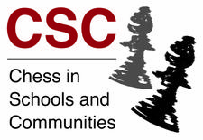
To register your interest and more information please contact: Peter Cloudsdale - cloudsdale_c@hotmail.co.uk

